**International School, Duy Tan University**



CAPSTONE PROJECT 2

An Phu Farm System

**HIGH LEVEL DESIGN**

**DOCUMENT**

Version 1.0

05/03/2016

**Mentor : MSc. Nguyen Minh Nhat**

**Group name : Divine Team**

**Document Information**

|  |  |
| --- | --- |
| Project | An Phu Farm System |
| Document Title | High Level Design Document |
| Creator | Le Dinh Doan |

**Revision History**

|  |  |  |  |
| --- | --- | --- | --- |
| Version | Person | Date | Description |
| 1.0 | Le Dinh Doan | 05-March - 2016 | Offical |

**Document Approval**

The following signatures are required for approval of this document

**Prepared by**

Doan Hai Dang Date

*Team Leader 05/03/2016*

Contents

1. Introduction 5

1.1. Purpose 5

1.2. Scope 5

2. Project statement 5

2.1. Project overview 5

2.2. Project background 6

2.3. Project goal 6

2.4. System context diagram 7

3. OST Architectural Driver 8

3.1. Business Constraints 8

3.2. Technical Constrain 8

3.3. Function Requirement 9

3.4. Quality Attributes 16

4. Architectural Overview 17

4.1. Concept Diagram 17

4.2. Class Diagram 17

1. **INTRODUCTION**
   1. **Purpose**

A high-level design document provides an overview of a solution, platform, system, product, service, or process.

Such an overview is important in a multi-project development to make sure that each supporting component design will be compatible with its neighboring designs and with the big picture.

* 1. **Scope**

This document is written for Divine team use to describe architectural overview of the system through diagrams.

1. **Project statement**
   1. **Project overview**

|  |  |
| --- | --- |
| Project name: | An Phu Farm System |
| Mentor: | MSc. Nguyen Minh Nhat |
| Developer team: | Doan Hai Dang  Le Hoang Phuc  Le Dinh Doan  Nguyen Ba Chinh |

* 1. **Project background**

Nowadays, more and more hurtful food in market. It affected to people about healthy and disease. With An Phu Farm system, customer can have a live connect with An Phu Farm shop to search, booking fresh foods and another features. Everything become easily and convenient for improve healthy and quality of the life.

When the system is implemented successfully, An Phu Farm shop can increase competitive ability, grow the business performance and maximize the profits. Additionally, the system will be developed with a web application to help user accessing anywhere, anytime. And have ability to upgrade, update the new functions to meet the user requirements.

* 1. **Project goal**

Table 2.1 Project Goal

|  |  |
| --- | --- |
| **Goal** | **Description** |
| Software | Design an An Phu Farm System full function, nice and friendly interface. |
| Business | Meet the customer’s need. |
| Technology | Use the latest technology and suitable for many computer. |
| Quality | Defect is at least |
| Team member | Corporation to develop together. |
| Process | Support project is on time, on budget, assurance software quality and motivate team works. |

* 1. **System context diagram**

This view defines the context of the system during normal operation

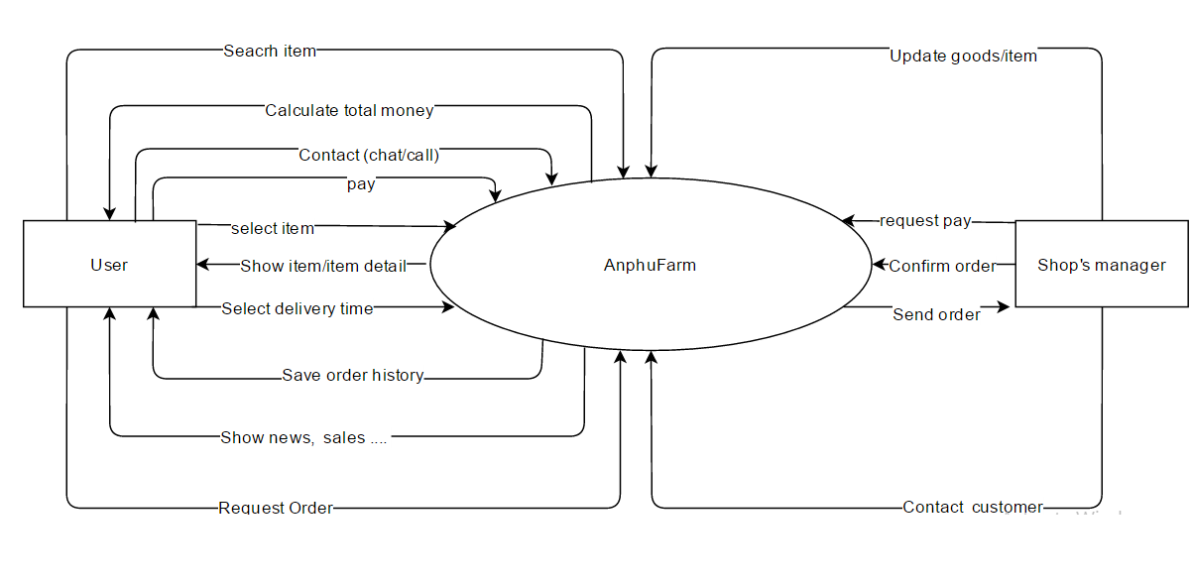

Figure 2.1: System Context Diagram

1. **OST Architectural Driver**
   1. **Business Constraints**

Project begins from January 26, 2016 to May 20, 2016.

* 1. **Technical Constrain**

Development technology constraints: technology is allowed to use to implement the project.

Website: Spring Web MVC with JSTL and Android. Using Eclipse.

Web service and input database: Spring Web service with json, Sqlite in Android.

Database System: MySQL 6.3, Sqlite browser.

Internet

Eclipse with Spring tools and Android SDK.

Database environment: Web service

Signature of the parties related to the project: The representative of An Phu Farm shopand Divine team

* 1. **Function Requirement**
     1. **Use Case Overview**

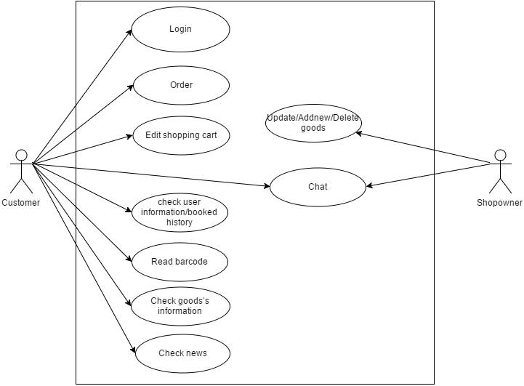

Figure 3.1: Show good information

* + 1. **Use Case 1: Login**

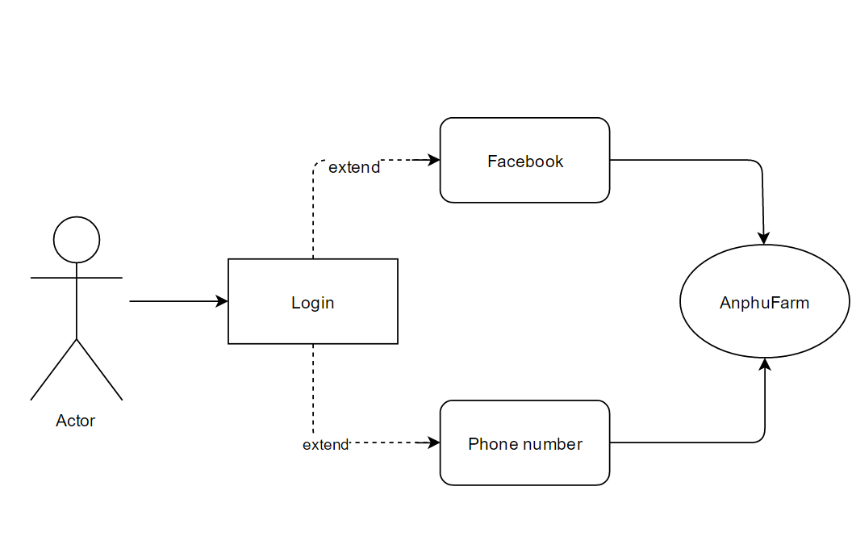

Figure 3.2: Login

* + 1. **Use Case 2:** **Show goods’s information**

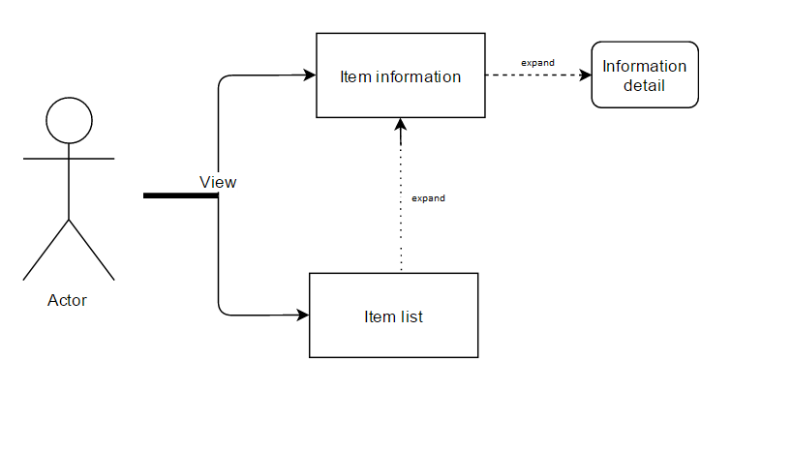

Figure 3.3: Show good information

* + 1. **Use Case 3:** **Show goods’s list**



Figure 3.4: Show goods’s list

* + 1. **Use Case 4: Shopping cart**

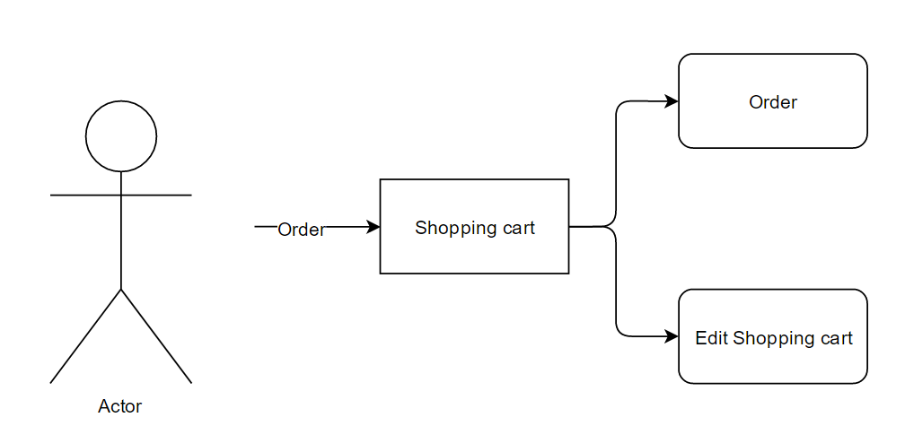

Figure 3.5: Shopping cart

* + 1. **Use Case 5: News**

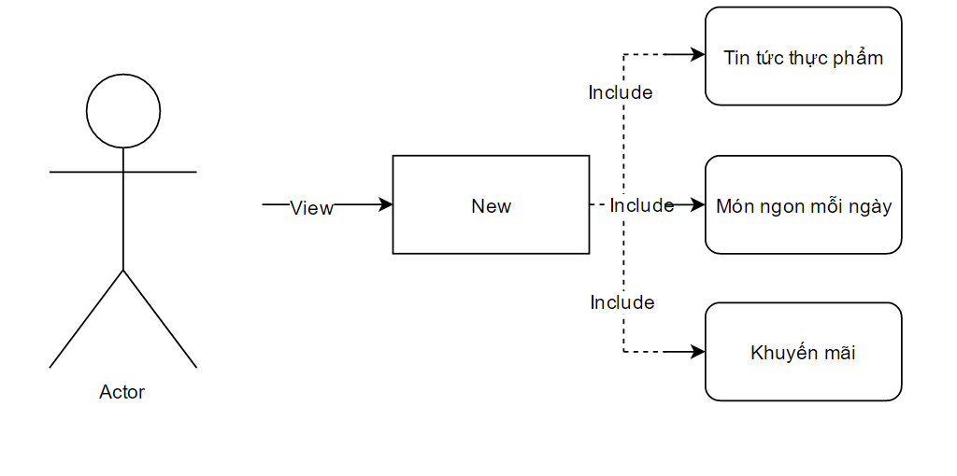

Figure 3.6: News

* + 1. **Use Case 6: Chat**

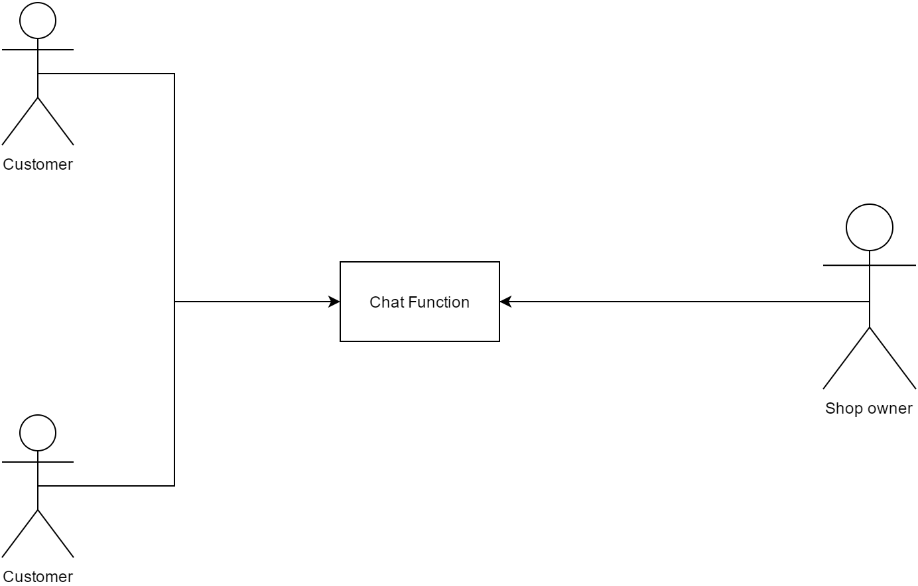

Figure 3.7: Chat

* + 1. **Use Case 7: Barcode reader**

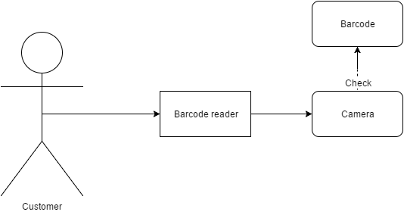

Figure 3.8: Barcode reader

* + 1. **Use Case 8: User’s information**



Figure 3.9:User’s information

* + 1. **Use Case 9: Show booked ’s history**

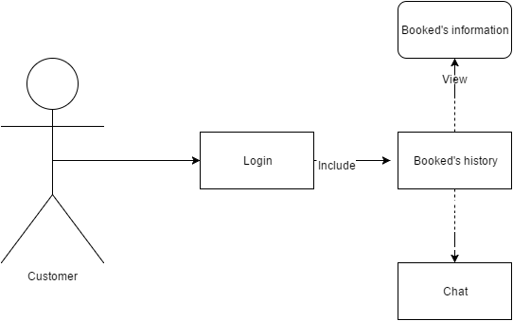

Figue 3.10: Show booked ’s history

* + 1. **Use Case 10: Show goods follow to category**



Figure 3.11: Show goods follow to category

* + 1. **Use Case 11: Payment Online**



Figure 3.12: Pay ment Online

* 1. **Quality Attributes**

Table 3.1 Quality Attributes

|  |  |  |  |  |
| --- | --- | --- | --- | --- |
| **Attributes** | **Concerns** | **Requirements Engineering** | **Constraints** | **Priority** |
| Usability | UI friendly, easy to upload survey | - Easy to use the tool. | - Allows users to login with confirm code in two second | H |
| Performance | Response time | - Time to load data from server less than 10 second |  | M |
| Security | Security | - Create private Admin page to avoid hack JavaScript.  - Use Authentication technical  - Manage account and Authorization.  - Setting permissions and using Web service | - Install the software management system to avoid virus, DDOT …  - Customer password over 8 characters. | H |
| Maintainability | Maintain | - Time is maintained to ensure the use of tool users are sure that their absolute satisfaction.  - The cost of maintenance to make sure that not too much loss budget of the customer | - During maintenance should consider the fault of the tool carefully to upgrade to next version. | L |
| Testability | Testing | - Check the technical errors in the period. - If an error is to find the origin and the repairs promptly. | - Thoroughly tested - Minimize error to level allowed | L |

1. **Architectural Overview**
   1. **Concept Diagram**
   2. **Class Diagram**

|  |  |  |
| --- | --- | --- |
| ***Prepared by*** | ***Signature*** | ***Date*** |
| Doan Hai Dang  Mr    K18CMUTPM1 | | / / |
| Le Hoang Phuc  Mr    K18CMUTPM1 | | / / |
| Le Dinh Doan  Mr  K18CMUTPM1 | | / / |
| Nguyen Ba Chinh  Mr  K18CMUTPM1 | | / / |
| ***Approved by*** | ***Signature*** | ***Date*** |
| Nguyen Minh Nhat  Msc, Mentor  Duy Tan University | | / / |